**Adaptive Programming | UML Diagram – Summatieve Opdracht 1**

Justin Klein – 1707815

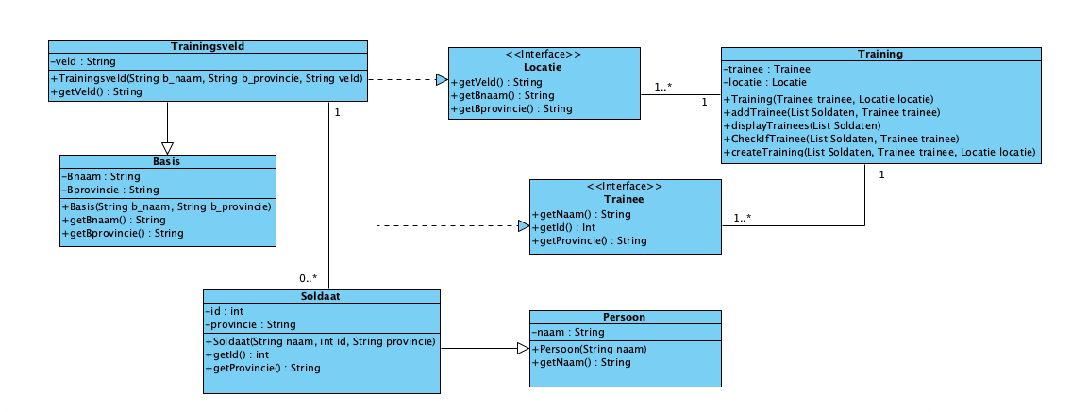Klas: V1B